**M6932 Air Traffic Control**

**Tutorial Aviation Emission Analysis**

**Date Release: 18th March**

**Date due 24th March**

**Student Name:_____________________________**

**Student ID______________________**

Singapore International Airline would like to renew its fleet of Airbus A330-300, which is currently fitted with Rolls-Royce Trent 700 Engines, with new generation of environmentally friendly engines.

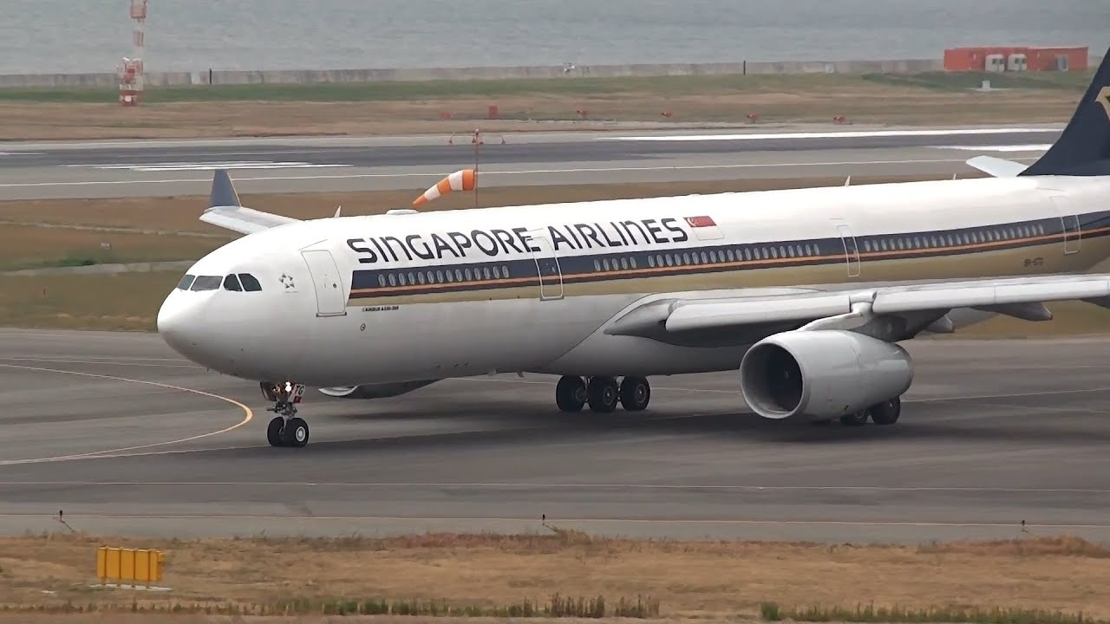

As an Aviation Consultant, you are hired to evaluate following four jet engines and make recommendations:

1. Rolls-Royce Corporation AE3007A2 with Type 3 (reduced emissions)
2. CFM International CFM56-7B20/3 with Tech Insertion
3. GE Aircraft Engines CF34-8C5B1 with Low Emission Combustor
4. Pratt & Whitney JT8D-7 series with Reduced emissions

The Singapore International Airline is specifically concerned with CO2 and NOx emissions in Landing and Take-off cycle (LTO).

Use chart/graph to present your findings.